**Title:** Home Automation Management System

**Description:**

In this task, we try to implement a home automation database management system. At First, we create a database to store the entries or pieces of information about the home. The database name is automation.sql. Here in this database, we create three tables and each table contains 3-4 rows and attributes. In this task, there are three Entities

1. Rooms

2. Devices

3. StatusDevice.

And the attributes are RoomID, Floor, Name, DeviceID, DeviceName, Status, Date, Hour(For timing). For the SQL Creation, we made some commands using SQL Scripting Language Here we Implement INSERT, SELECT, DELETE, UPDATE, GROUP BY, And join Commands. After execution, all outcomes are attached here.

**Attributes & Entities:**

There are three Entities.

1. Rooms

2. Devices

3. StatusDevice

And the attributes are RoomID, Floor, Name, DeviceID, DeviceName, Status, Date, Hour(For timing).

1. **R Diagram:**

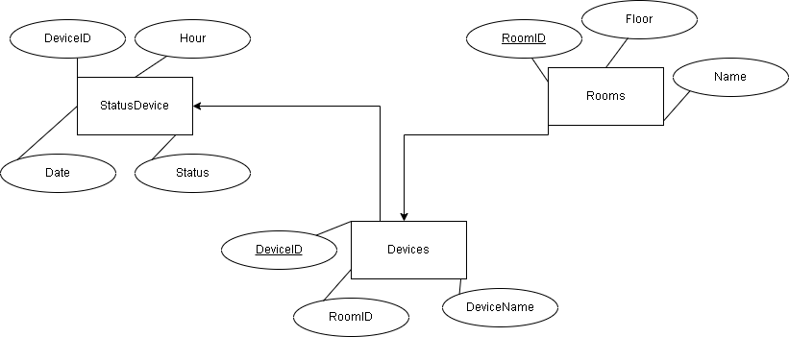

**Codes:**

**Insert Statement:**

INSERT INTO `rooms`(`RoomID`, `Floor`, `Name`) VALUES ('12','2ND','B')

INSERT INTO `rooms`(`RoomID`, `Floor`, `Name`) VALUES ('13','3RD','C')

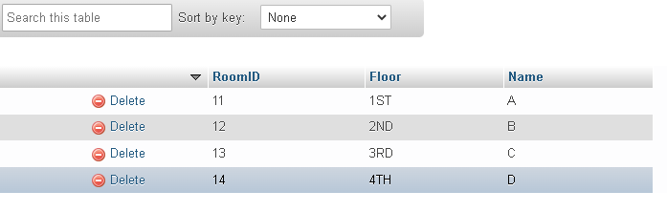

**Update Statement:**

UPDATE `statusdevices` SET `DeviceID`='100' WHERE `DeviceID`='101'

Before Update:



After Update:

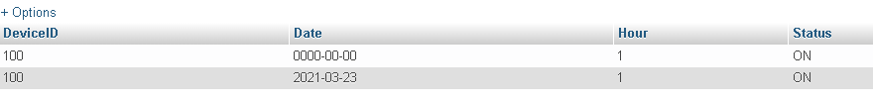

UPDATE `rooms` SET `Floor`='3RD' WHERE `Floor`='4TH'

Before Update:



After Update:



**Delete Statement:**

DELETE FROM `statusdevices` WHERE `Date` IS NULL

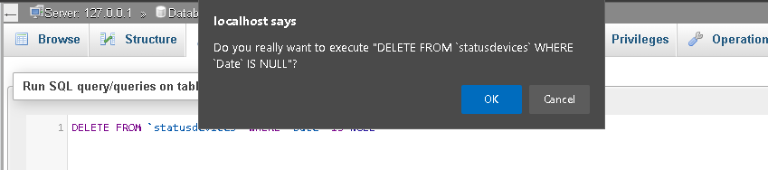

After Delete:

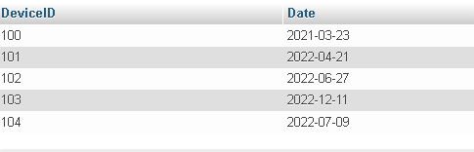

**Select Statement:**

SELECT * FROM `rooms` WHERE 1

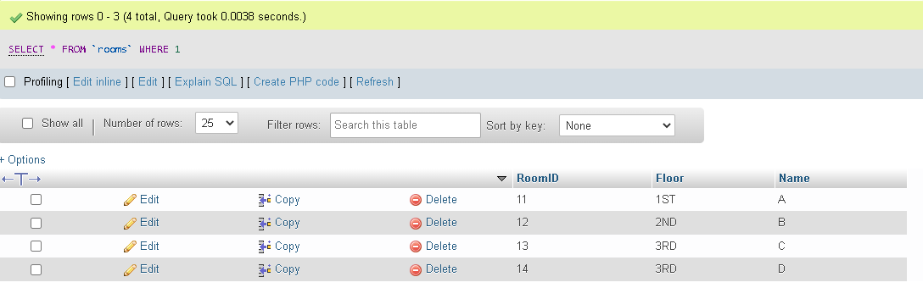

**Join Statement:**

SELECT rooms.RoomID, DeviceID FROM `rooms` JOIN `devices` ON rooms.RoomID=devices.RoomID

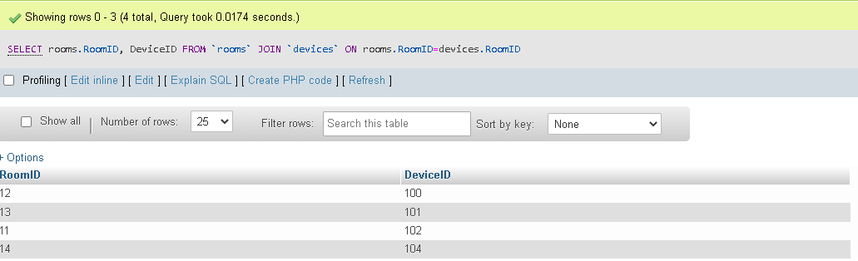

SELECT devices.DeviceName, devices.RoomID, statusdevices.Status FROM `devices` JOIN `statusdevices` ON devices.DeviceID=statusdevices.DeviceID

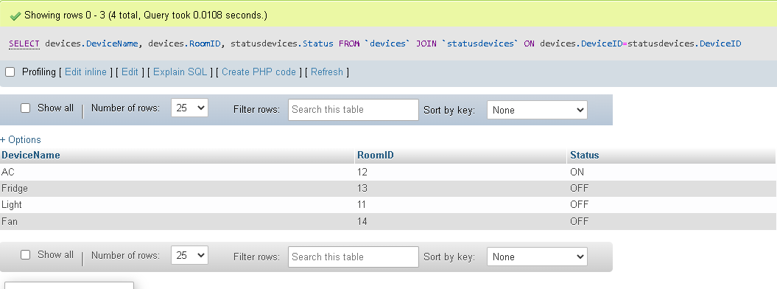

**Summary Statement:**

SELECT DeviceID, Status FROM `statusdevices` WHERE 1 GROUP BY DeviceID

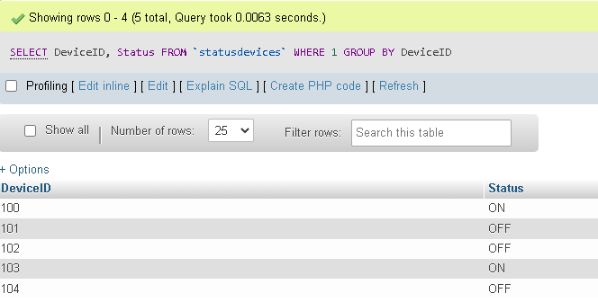

SELECT `RoomID`, `Floor`, `Name` FROM `rooms` WHERE 1 GROUP BY `RoomID` AND `Floor`

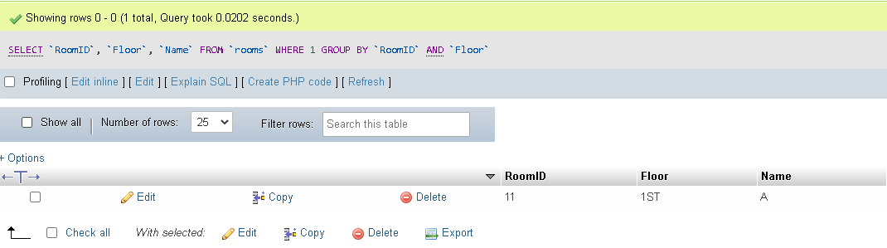

SELECT COUNT(`DeviceName`) FROM `devices` WHERE DeviceID IS NOT NULL

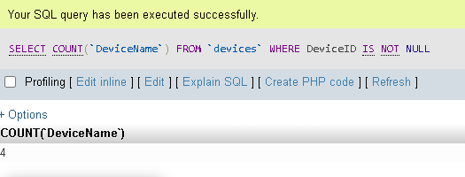

**Multi-Table Query:**

SELECT rooms.RoomID, devices.DeviceName FROM rooms, devices WHERE rooms.RoomID = devices.RoomID

